GUI Manual Draft (Content Only, No Formatting)

# Introduction

This user manual contains the theory and operating instructions for the VT BiPAP monitoring device. The following sections will explain how to download the associated program, install the device on a BiPAP machine, and use the program to monitor the volumetric flow rate supplied to the patient. Additionally, there is a section containing solutions to common operating issues. Note that this user manual does not cover every detail about the device and the user should contact the authors for further questions.

# Theory

The BiPAP monitoring device was designed to show the volumetric flow rate of the air supplied by the BiPAP machine in real time. In an event where ventilators are low in supply, the BiPAP machine is now one step closer to a replacement for a ventilator with the addition of the monitoring device and computer. The main functions of the monitoring device are to track the volumetric flow rate of the supplied air, alert medical personnel when critical conditions are detected, and provide a connection to a computer to show real time measurements.

## Design of the monitoring device

[Venturi diagram of device]

The monitoring device relies on the Venturi effect to measure the difference in pressure to calculate the volumetric flow rate of the BiPAP machine. The air passes through a constricted section of the Venturi, where there is a reduction in pressure that is recorded by two pressure transducers connected to a microcontroller within the box. Using the pressure difference, the microcontroller calculates the velocity using Bernoulli’s Principle, which gives enough information to find the flow rate. Since the areas of the inlet and outlet of the device are the same, the flow is mostly unaffected by the addition of the device.

## Calculating the volumetric flow rate

To calculate the volumetric flow rate, pressure transducers are used to measure the differences in pressure from the inlet and constricted section of the Venturi meter. Using Bernoulli’s principle,

[Equation 1: Bernoulli’s Equation]

the pressure difference is back calculated to obtain the velocity of the flow, which is used to calculate the flow rate using,

[Equation 2: Q=AV]

Since it is natural for the pressure transducers to measure differently from the BiPAP machine, the device was also calibrated to obtain more accurate measurements. After calibration, a single constant was determined to represent the differences between the measured and actual flow rates using,

[Equation 3: Calibration equation]

For this device, the calibration constant was determined as ___. All the calculations were done assuming:

* Incompressible flow
* Density = X
* Mixture of air only/mostly contains O2, H2O, CO2, N2
* Etc…

# Download Instructions

[TBD]

# Connecting the machine

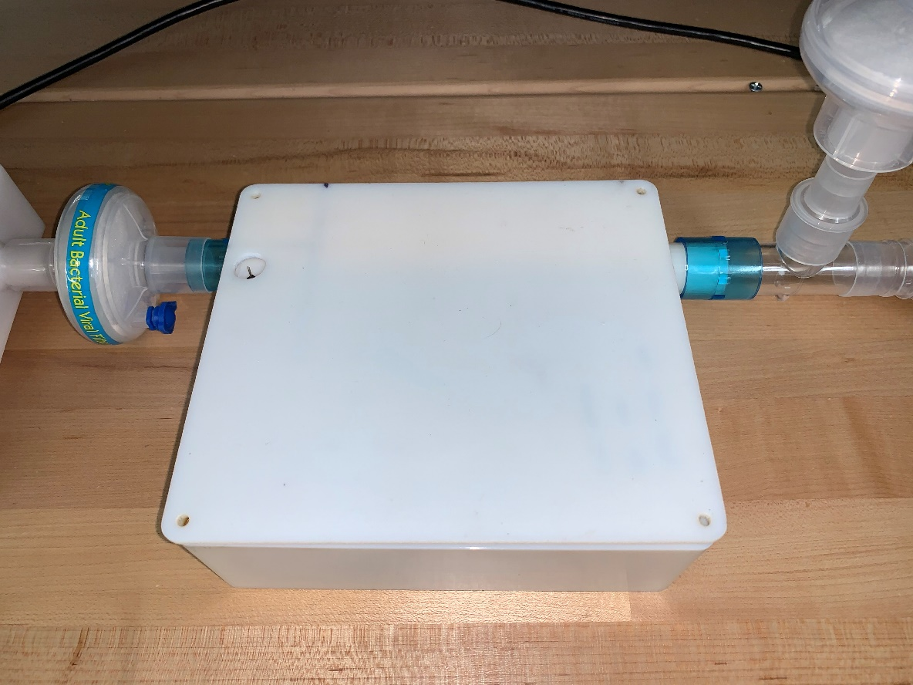

3

1

2

**Figure 1**: Overall set up for the BiPAP monitoring device

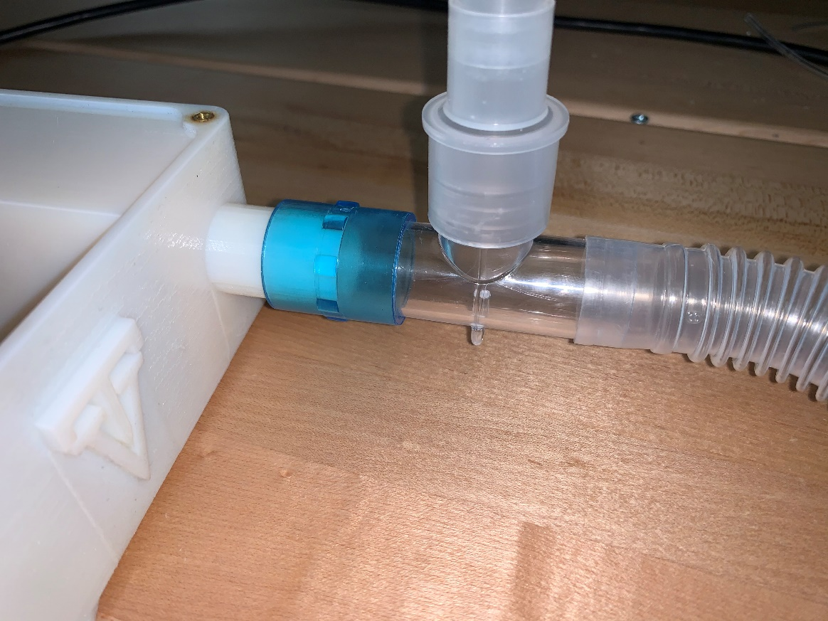

**Figure 2:** Connection between the BiPAP machine and the monitoring box for Figure 1-1

1. Connect the hose from the BiPAP side to one side of the blue connector and the other side of the connector to the right side of the device. The hoses should fit inside the blue connector, as shown in Figure 2.

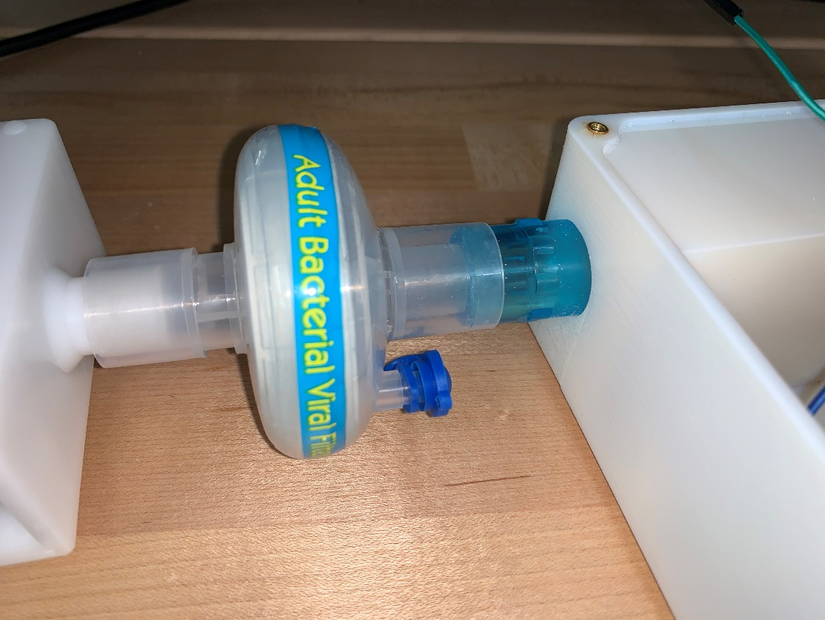

**Figure 3**: Connection between the patient and the monitoring box for Figure 1-2

1. Connect the hose from the patient side to one side of the blue connector (Figure 1-2) and the other side of the connector directly into the left side of the devie. The hose should fit over the connector as shown in Figure 3.

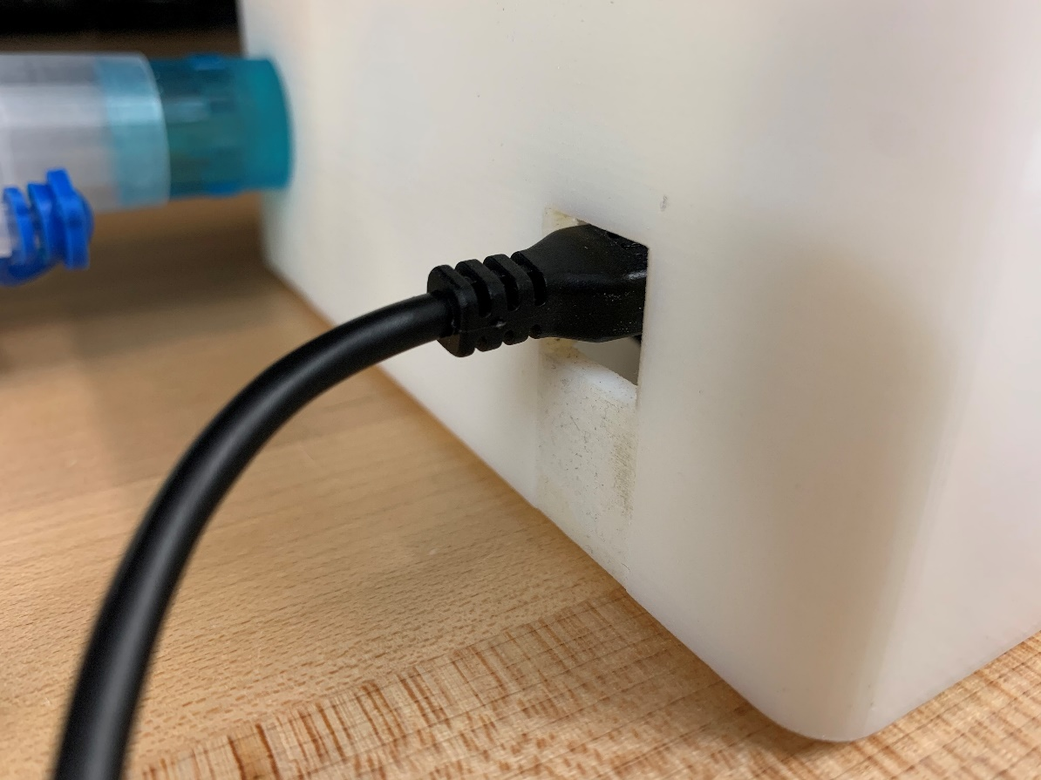

**Figure 4:** Connection between the computer and the monitoring box for Figure 1-3

1. Connect the USB cable to the left side of the device as shown in Figure 4. Then, connect the other side of the cable to a computer with the program installed. Now, the monitoring device is on and powered up.
2. Plug the BiPAP machine to power.

# Operation

1. Double click the BiPAP program in the desktop [Figure missing]

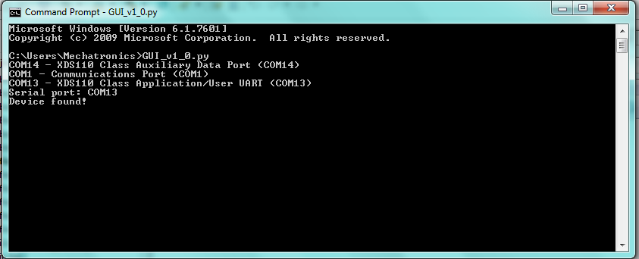

1

2

3

**Figure 5**: Inputs for the command window after opening the program

1. Wait for the command window to open. It will ask you to enter the Serial port as shown in the Figure 5-1. Press Enter on the keyboard complete line.
2. Type in the COM port for the option that has the name “XDS110 Class Application/User UART”. In this case, it is COM13 as shown in Figure 5-2. Press Enter on the keyboard to complete line.
   1. If there are no errors, the command window will output “Device found!” as shown in Figure 5-3. If there are errors, refer to the section “Common Issues” to find a solution fix.

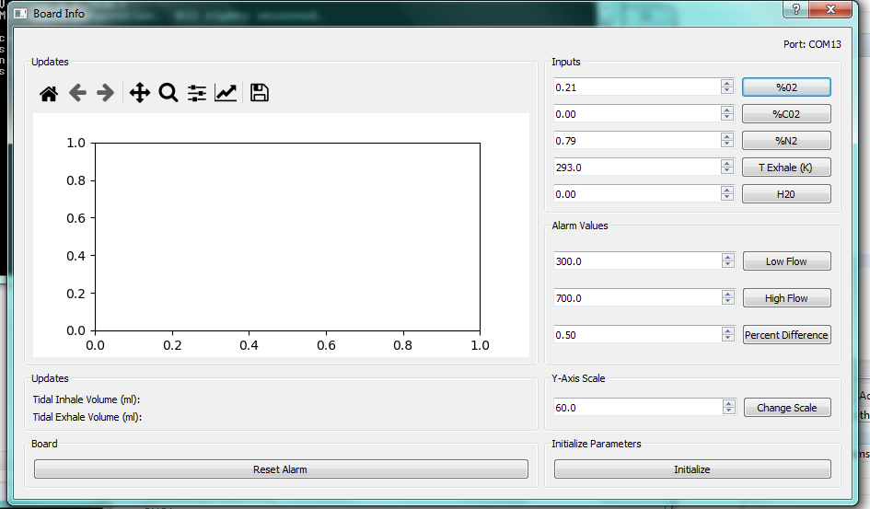

5

2

4

3

1

**Figure 6:** The initial screen of the monitoring program

1. Wait for the program to open in a second window with all the loaded features. The screen should look like the window in Figure 6.
2. Double-check that all the property inputs in Figure 6-1 for the environment are correct.
   1. The default input values are 21%mass for O2, 0.0%mass for CO2, 79%mass for N2, 0%mass for H2O, and 293K for the exhale temperature.
   2. Note that the percentages are in decimal in the program and should be entered as such.
   3. If needed, manually change the inputs within the textboxes.
3. Enter the limits for the flow that will set off the alarm as labeled in Figure 6-2.
   1. The default alarm threshold values are 300ml for Low Flow, 700ml for High Flow, and 50% percent difference between the inhale and exhale volumes.
   2. Note that the percentages are in decimal in the program and should be entered as such.
   3. If needed, manually change the inputs within the textboxes.
4. Enter the desired scale for the y-axis to clearly show the measured data as labeled in Figure 6-3.
   1. The default y-axis scale is set to +/- 60 LPM.
   2. If needed, manually change the inputs within the textboxes.
5. Once all the information for the environment, alarm, and scale is verified, click the initialize button (Figure 6-4). This will save the new values.
6. Start the BiPAP machine with normal operation. See the BiPAP machine’s user manual for more information.

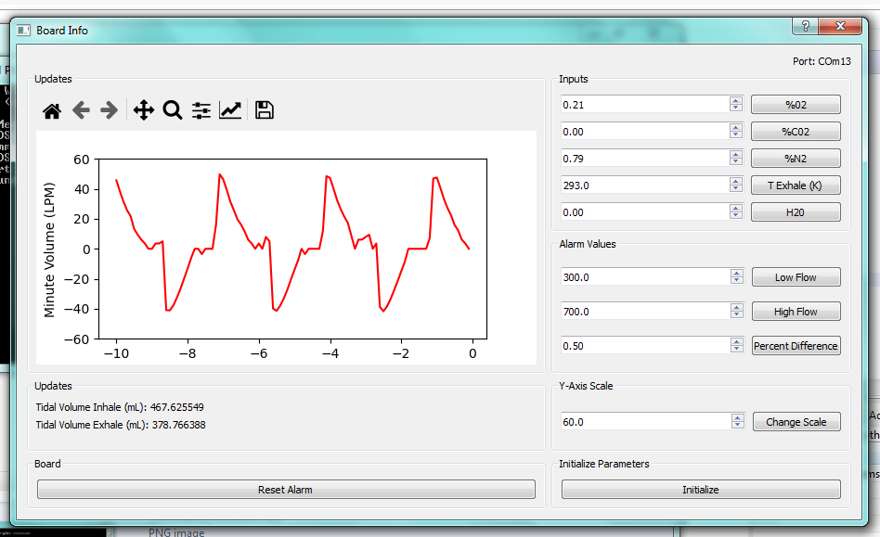

2

1

**Figure 7:** The screen of the monitoring program while measuring flow

1. The program will now start monitoring the flow rate of the machine, which is shown in the Figure 7.
   1. You should be able to see a clear distinction between the inhale and exhale peaks, as shown in Figure 7-1.
2. Note: The maximum and minimum volumes are displayed and updated in real time under the graph in ml (Figure 7-2)
3. If the graph is not centered and within the boundaries, change the y-axis limits in the textbox
   1. Click *Initialize* again after updating the value
4. If the alarm sounds, reset the alarm by clicking *Reset Alarm* as labeled in Figure 6-5.
   1. Conditions for sounding alarm
      1. The volumetric flow rate exceeds the given limits
      2. The BiPAP machine is disconnected while running program
      3. The program is does not detect airflow (0 LPM) for over 3 seconds
5. If more input values need to be changed, update the values in the textboxes and click *Initialize*

# Power Down Sequence

1. Close the computer program by clicking the “X” in the top right hand corner
2. Unplug the USB cable from the computer and the device.
   1. Always ensure the cables are stored properly to prevent damage and loss
3. Turn off the BiPAP machine

# Common Issues

## The device cannot be found

1. Solution 1
   1. Enter the COM port again
2. Solution 2
   1. Open the Device Manager by searching “device manager” in the lower left hand corner of the screen
3. Solution 3
   1. Close the command prompt (Windows Powershell) window
   2. Unplug the device
   3. Plug the device back to the computer
   4. Restart program

## BiPAP machine detects low flow

1. Double check the connections in Figure 1-1 and Figure 1-2
2. Ensure that there are no leaks
   1. If leaks are found, replace the blue connectors
   2. If the issue persists, replace the hoses